

Dr. Maria, Harris inc.

2021-12-24

Dr. Harris

71331 Morgan Corners, Bookerberg, OH 13639

Phone: 2367531302

Fax: 7113939278

**Re:** Cassandra, Santos

**PHN:** 4899707530

**Birthdate:** 23-Sep-1949

**Address:** 6564 Silva Lakes Apt. 010, West Christine, WI 15559

**Patient number:** 5809588367

To Whom It May Concern:

This is a medical letter to state the above patient is pregnant with expected delivery date of 27-Jul-2025. Hoping this information is satisfactory for your requirements.

Thank you.

Sincerely,

Dr. Maria, Harris

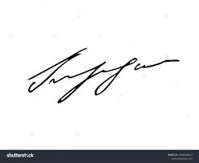

FRCS© NCMP

Clinical Assistant Professor, UBC

Department of Obstetrics and Gynecology SMH